How to Reduce Your Exposure to Plastic in Food (and Everywhere Else)
By Lauren F. Friedman
January 4, 2024
Editor’s Note: This article appeared in the February 2024 issue of Consumer Reports magazine. The link to the article is:
https://www.consumerreports.org/health/food-contaminants/how-to-reduce-exposure-to-plastic-in-food-everywhere-else-a9640874767/?EXTKEY=NF41NCB3&utm_source=acxiom&utm_medium=email&utm_campaign=20240120_nsltr_food&utm_nsltr=food&utm_segment=basic

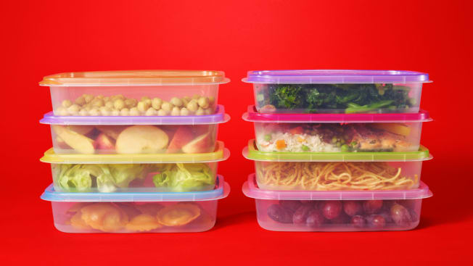Photo: Sarah Anne Ward
It's nearly impossible to completely avoid bisphenols and phthalates. But several small, strategic shifts can help.
Plasticizers—the most common of which are called phthalates—are used to make plastic more flexible and more durable. They’re so widely used that today, they show up inside almost all of us, right along with other chemicals found in plastic, including bisphenols such as BPA. Both types of chemicals have been linked to a long list of health concerns, even at very low levels. (Read our full report on these chemicals, "The Plastic Chemicals Hiding in Your Food," which includes the results of our tests of 85 food products.)
While most experts agree that big policy changes are needed to address the health risks posed by phthalates and bisphenols, in the meantime, there are some things you can do to help protect yourself and your family.
Get phthalates out of our food!
Tell the FDA to take action now to protect our families. Sign the petition. Read the full petition.

By submitting this form, I agree to the terms of Consumer Reports' Privacy Policy and User Agreement.

In Your Food
Limiting exposure to phthalates isn’t as simple as avoiding particular types of packaging, because these chemicals can enter your food long before it is packaged. The best solution, says Maricel Maffini, PhD, a chemical safety expert and the author of a recent study of phthalate risks, would be for manufacturers and regulators to ensure that our food was safe, so we wouldn’t “have to make these decisions when we go to the grocery store.” But that doesn’t mean you’re powerless now.
Reducing your overall exposure to the chemicals in plastic—including bisphenols and phthalates—may help you avoid some of the risks. These six steps can help.
Avoid plastic food storage containers. If you do use them, don’t heat them in the microwave, and avoid using them to store hot food, because heat can increase leaching. You can see CR’s top picks for glass and steel food storage containers. And keep your food below the top of the container to avoid contact with the lids, which are often plastic.
Steer clear of fast foods. Plasticizers are one more reason to limit consumption of fast food. Our testing found some of the highest levels of phthalates and phthalate substitutes in fast food. Although we can’t say exactly why, one possible explanation is that fast foods are often prepared by people wearing vinyl gloves, which are known to be extremely high in these chemicals.
Limit high-fat foods. Another reason fast foods may be high in plasticizers is that they tend to be fatty, and some research has found higher levels of plasticizers—many of which are known to be fat-soluble—in foods with higher fat content. One 2020 review, for example, reported that levels of DEHP were often almost five to 10 times higher in cream than they were in milk.
Eat fresh, minimally processed food. Make sure your diet includes plenty of unpackaged fruits and vegetables, which have fewer chances to have contact with phthalates. A study based on 2013 to 2014 data found that people who ate more ultraprocessed foods—such as french fries and ice cream pops—had higher levels of certain phthalate byproducts in their urine.
Choose wood, stainless steel, and silicone for kitchen tools. Chopping on a plastic cutting board can generate microplastics, so consider a wood or silicone board instead. Some plastic uses are probably riskier than others—dumping hot food into a plastic bowl and using plastic wrap for leftovers may expose you more than giving your lettuce a quick dry in a plastic salad spinner, for example.
Use water bottles made of glass or steel. Avoid plastic bottles and cups, which are often made with bisphenols. Carrying around your own stainless steel straws can also make it easy to say no to plastic straws. As a bonus, you’ll reduce the amount of trash you generate.

In Your World
Food is not the only way you’re exposed to bisphenols and phthalates, so if you want to reduce your exposure to endocrine-disrupting chemicals, you have to think broadly. Phthalates, for example, which are a viscous liquid in their raw form, are also a common ingredient in perfumes, cleansers, shampoos, and other cosmetics, and are sometimes used in flooring and furniture. Bisphenols and phthalates are also often found in household dust. Here are a few smart steps you can take.
Go fragrance-free. Soap, cosmetics, and cleaners with fragrances often use phthalates, especially DEP, as a solvent.
Open your windows. Because phthalates can be used in furniture, shower curtains, and flooring, they can accumulate in household dust, which you can then inhale. “Ventilation is important,” says Akhgar Ghassabian, MD, PhD, at the NYU Grossman School of Medicine. “And if you’re vacuuming, make sure you do that with the window open.”
Refuse paper receipts. Go for the digital ones instead; thermal paper receipts (the ones that are a little glossy) are often coated in bisphenols.
Limit your use of vinyl. Plasticizers are generally a key ingredient in vinyl products. When possible, choose alternate materials for shower curtains, flooring, car interiors, and clothing, says Amy Ziff, the founder of Made Safe, an organization that has partnered with CR to identify potentially harmful ingredients in products. She says vinyl is sometimes called “vegan leather.”
More on Plastic
The Plastic Chemicals Hiding in Your Food
Fast Food Companies Are Replacing One Toxic Chemical With Another
How to Eat Less Plastic
The Big Problem With Plastic

Lauren F. Friedman leads the health and food content team at Consumer Reports. Before joining CR in 2016, she worked as an editor at Business Insider and Psychology Today. She has also written for Scientific American, the Philadelphia Inquirer, and other publications. She is an adjunct lecturer at the Craig Newmark Graduate School of Journalism at the City University of New York, where she teaches Introduction to Health Journalism. She lives in Queens, N.Y.

