District | Representative | Party | CPVI | Incumbent time in office | District map
1st | 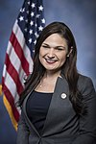 Abby Finkenauer (D–Dubuque) | Democratic | D+1 | January 3, 2019 – present | 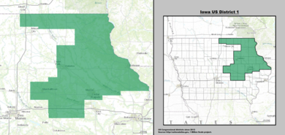
2nd |  Dave Loebsack (D–Iowa City) | Democratic | D+1 | January 3, 2007 – present | 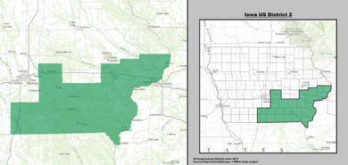
3rd |  Cindy Axne (D–West Des Moines) | Democratic | R+1 | January 3, 2019 – present | 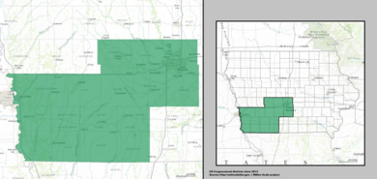
4th |  Steve King (R–Kiron) | Republican | R+11 | January 3, 2003 – present | 